QUESTION 1: BISECTION METHOD
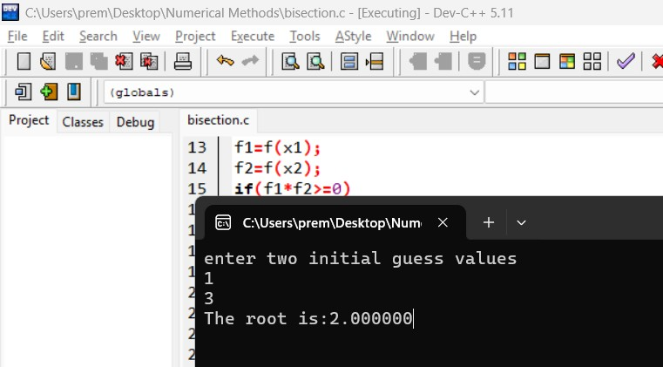

QUESTION 2: FALSE POSITION METHOD
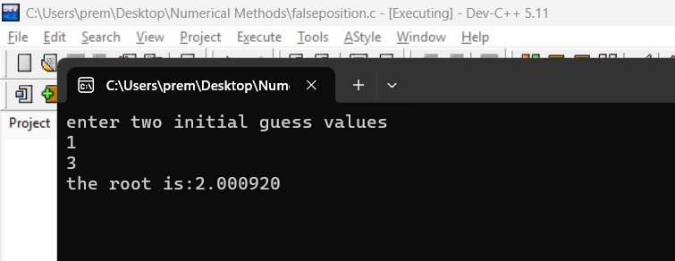

QUESTION 3: NEWTON RAPHSON METHOD
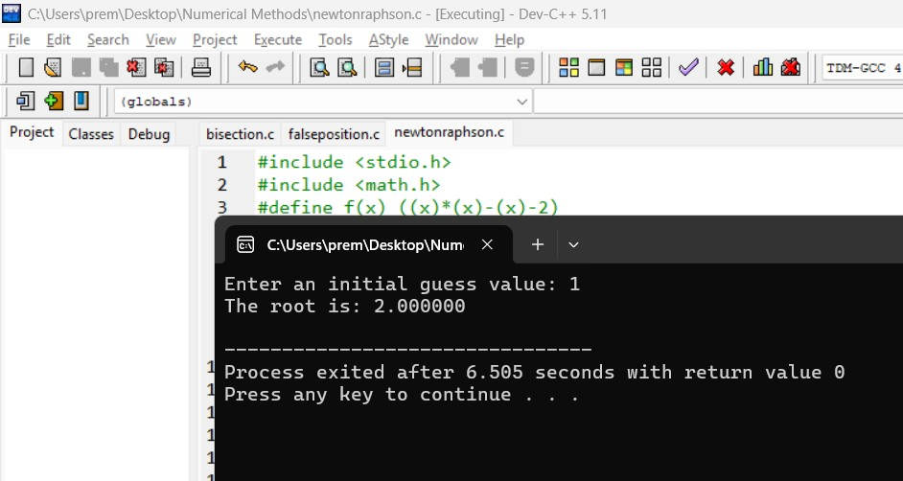
QUESTION 4: SECANT METHOD
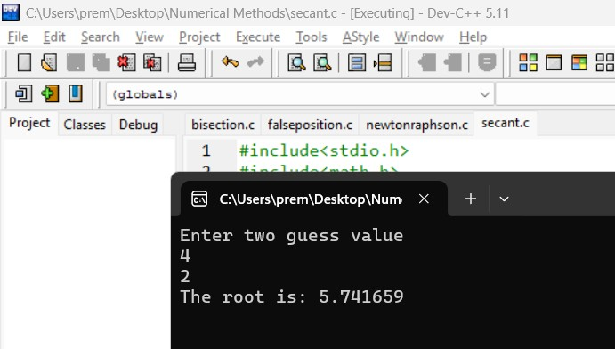

QUESTION 5: FIXED POINT ITERATION METHOD
